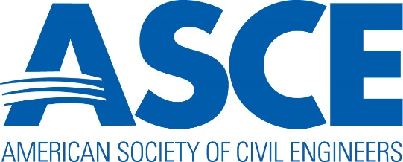

SOCIETY AWARD NOMINATIONS

A Guide: How to Create a Nomination Package

January 30, 2024

INDEX

Welcome page 2

Inventory of Society Awards (alphabetically) page 3

Inventory of Society Awards (by area) page 7

ASCE Recognitions Explained page 11

How to Nominate a Paper page 12

How to Nominate a Person page 17

How to Nominate a Project page 24

How to Nominate an Educational Program page 31

WELCOME

Thank you for your interest in ensuring the American Society of Civil Engineers recognizes outstanding engineers for their contributions to the profession through the Honors and Awards Program.

The Society boasts an inventory of 94 Society Awards, apart from those presented by institutes, divisions, and others. Society Awards are considered more prestigious than any other awards. Past winners often cite Society Awards for advancing their careers. It is only through the efforts of nominators who formally present their candidates for consideration that ASCE can continue these important recognitions.

Who can nominate? Self-nominations are strongly discouraged, and many Society Award rules forbid it. Nominators are not required to be ASCE members, but those who nominate are generally Society members.

If you are interested in nominating for Distinguished Membership, please understand the requirements are unique to that program. Please refer to information and to download forms on the web at https://www.asce.org/career-growth/awards-and-honors/distinguished-members.

This guide will assist those interested in nominating a paper, person, project, or program for an ASCE Society Award. The process outlined in the following pages is for Society Awards only and is meant to guide the nominator in creating a complete nomination package tailored to a specific Society Award. A complete list of Society Awards begins on page 3.

If you are unclear about which award fits your candidate, we invite you to review the inventory by area on page 7.

You will find information specific to each Society Award at https://www.asce.org/career-growth/awards-and-honors.

Each section in this guide explains the documents required to present a complete package. You will also find an example for reference.

If you have questions not answered in this guide, we invite you to contact awards@asce.org.
Jane Moran Alspach, Aff.M.ASCE
Director, Honors and Awards
INVENTORY OF SOCIETY AWARDS – PRESENTED ALPHABETICALLY
For further information, visit awards@asce.org
Highlighted Society Awards recognize outstanding published papers.

SOCIETY AWARD | ENGINEERING DISCIPLINE
Ang Award on Risk Analysis & Management of Civil Infrastructures, Alfredo | Civil Infrastructure
Arid Lands Hydraulic Engineering Award | Environmental Engineering
Bartholomew Award, Harland | Transportation Engineering
Bazant Medal for Failure & Damage Prevention, Zdenek P. | Civil Infrastructure
Bechtel Pipeline Engineering Award, Stephen D. | Pipeline Engineering
Bechtel, Jr Energy Award, Stephen D. | Energy Engineering
Bickel Award, John O. | Construction Engineering
Biot Medal, Maurice A. | Engineering Mechanics
Can-Am Civil Engineering Amity Award | Professional Development & Civil Achievement
Casagrande Professional Development Award, Arthur | Geotechnical Engineering
Cermak Medal, Jack E. | Engineering Mechanics/Structural Engineering
Ven Te Chow Award | Environmental Engineering
Civil Engineering History & Heritage Award | Civil Engineering History
Collingwood Prize | Younger Members
Columbia Medal | Aerospace Engineering
Computing In Civil Engineering Award | Computer Practices
Construction Management Award | Construction Engineering
Croes Medal, J. James R. | Engineering Science
Duke Lifeline Earthquake Engineering Award, Charles Martin | Lifeline Engineering
Einstein Award, Hans Albert | Environmental/Coastal Engineering
Frangopol Award for Life-Cycle Civil Engineering of Civil Structures, Dan M. | Structural Engineering
Freese Environmental Engineering Award & Lecture, Simon W. | Environmental Engineering
Freudenthal Medal, Alfred M. | Engineering Mechanics
Friedman Professional Recognition Award, Edmund | Professional Development & Civil Achievement
Friedman Young Engineer Award for Professional Achievement, Edmund | Younger Members
Greeley Award, Samuel Arnold | Environmental Engineering
SOCIETY AWARD | ENGINEERING DISCIPLINE
Halpin Award for Scholarship in Construction, Daniel W. | Construction Engineering
Hardesty Award, Shortridge | Structural Engineering
Hering Medal, Rudolph | Environmental Engineering
Hilgard Hydraulic Prize, Karl Emil | Environmental Engineering
Hinds Award, Julian | Environmental Engineering
Hoffman Award, Phillip R. | Energy Engineering
Horner Award, Wesley W. | Environmental Engineering
Housner Structural Control and Monitoring Award, George W. | Engineering Mechanics
Howard Award, Ernest E. | Construction/Structural Engineering
Huber Civil Engineering Research Prizes, Walter L. | Research and Innovation
Hydraulic Structures Medal | Environmental Engineering
Innovation in Civil Engineering Award | Sustainability
International Coastal Engineering Award | Coastal Engineering
Iwan Award for Mentors in Mechanics Research, Wilfred D. | Engineering Mechanics
Journalism Award, ASCE Excellence in | Journalism
Kapp Foundation Engineering Award, Martin S. | Geotechnical Engineering
Laurie Prize, James | Transportation Engineering
LeFevre Award, Walter | Ethics
Lin Award, T. Y. | Structural Engineering
Lund Award, Le Val | Civil Infrastructure
Magoon Sustainable Coasts Award, Orville T. | Coastal Engineering
Masters Transportation Engineering Award, Frank M. | Transportation Engineering
Mead Prize for Younger Members, Daniel W. | Younger Members
Mead Prize for Students, Daniel W. | Student Members
Michel Award for Industry Advancement of Research, Henry L. | Research and Innovation
Middlebrooks Award, Thomas A. | Geotechnical Engineering
Mindlin Medal, Raymond D. | Engineering Mechanics
Moffatt- Frank E. Nichol Harbor and Coastal Engineering Award, John G. | Coastal Engineering
Moisseiff Award | Structural Engineering
Mujumdar Resilience Award, Vilas | Structural Engineering
Newmark Medal, Nathan M. | Engineering Mechanics
SOCIETY AWARD | ENGINEERING DISCIPLINE
Noble Prize, Alfred | Engineering Science
Norman Medal | Engineering Science
Outstanding Public Official Award | Professional Development & Civil Achievement
Pankow Award for Innovation, ASCE Charles | Research and Innovation
Parcel-Leif J. Sverdrup Civil Engineering Management Award, John I. | Professional Development & Civil Achievement
Peck Award, Ralph B. | Geotechnical Engineering
Petersen Award, Margaret S. | Environmental Engineering
Peurifoy Construction Research Award | Construction Engineering
Peyton Award for Cold Regions Engineering, Harold R. | Cold Regions Engineering
Prakash Award and Lecture, Shamsher | Geotechnical Engineering
Presidents-Emeriti Council Award, ASCE | Professional Development & Civil Achievement
President’s Medal, ASCE | Professional Development & Civil Achievement
Professional Practice Ethics and Leadership Award, The | Ethics
Reese Research Prize, Raymond C. | Structural Engineering
Rickey Medal | Energy Engineering
Ridgway Student Chapter Award, Robert | Student Members
Roberts Global Sustainability Award, Donald V. | Sustainability
Roebling Award | Construction Engineering
Rouse Hydraulic Engineering Lecture, Hunter | Environmental Engineering
Rowland Prize, Thomas Fitch | Construction Engineering
Scanlan Medal, Robert H. | Engineering Mechanics
Seed Medal, H. Bolton | Geotechnical Engineering
Shinozuka Medal, Masanobu | Engineering Mechanics
Wilbur S. Smith Award | Transportation Engineering
Smith Hydraulic Fellowship, J. Waldo | Environmental Engineering
State of the Art of Civil Engineering Award, ASCE | Engineering Science
Stevens Award, J. C. | Environmental Engineering
Surveying And Mapping Award | Geomatics Engineering
Terzaghi Award, Karl | Geotechnical Engineering
Terzaghi Lecture, Karl | Geotechnical Engineering
Tipton Award, Royce J. | Environmental Engineering
Turner Lecture, Francis C. | Transportation Engineering
SOCIETY AWARD | ENGINEERING DISCIPLINE
Von Karman Medal, Theodore | Engineering Mechanics
Wellington Prize, Arthur M. | Transportation Engineering
Winter Award, George | Structural Engineering
Wisely American Civil Engineer Award, William H. | Professional Development & Civil Achievement
Younger Member Group Award | Younger Members

INVENTORY OF SOCIETY AWARDS – PRESENTED BY AREA
For further information, visit awards@asce.org
Highlighted Society Awards recognize outstanding published papers.

Aerospace Engineering
Columbia Medal
Civil Engineering History
Civil Engineering History & Heritage Award
Civil Infrastructure
Ang Award on Risk Analysis & Management of Civil Infrastructures, Alfredo | Bazant Medal for Failure & Damage Prevention, Zdenek P.
Lund Award, Le Val
Coastal Engineering
International Coastal Engineering Award | Moffatt- Frank E. Nichol Harbor and Coastal Engineering Award, John G.
Magoon Sustainable Coasts Award, Orville T.
Cold Regions Engineering
Peyton Award for Cold Regions Engineering, Harold R.
Computer Practices
Computing In Civil Engineering Award
Construction Engineering
Bickel Award, John O. | Roebling Award
Construction Management Award | Peurifoy Construction Research Award
Halpin Award for Scholarship in Construction, Daniel W. | Rowland Prize, Thomas Fitch
Construction/Structural Engineering
Howard Award, Ernest E.
Energy Engineering
Bechtel, Jr Energy Award, Stephen D. | Rickey Medal
Hoffman Award, Phillip R.
Engineering Mechanics
Biot Medal, Maurice A. | Newmark Medal, Nathan M.
Freudenthal Medal, Alfred M. | Scanlan Medal, Robert H.
Housner Structural Control and Monitoring Award, George W. | Shinozuka Medal, Masanobu
Iwan Award for Mentors in Mechanics Research, Wilfred D. | Von Karman Medal, Theodore
Mindlin Medal, Raymond D.
Engineering Mechanics/Structural Engineering
Cermak Medal, Jack E.
Engineering Science
Croes Medal, J. James R. | Norman Medal
Noble Prize, Alfred | State of the Art of Civil Engineering Award, ASCE
Environmental/Coastal Engineering
Einstein Award, Hans Albert
Environmental Engineering
Arid Lands Hydraulic Engineering Award | Horner Award, Wesley W.
Ven Te Chow Award | Hydraulic Structures Medal
Freese Environmental Engineering Award & Lecture, Simon W. | Petersen Award, Margaret S.
Greeley Award, Samuel Arnold | Rouse Hydraulic Engineering Lecture, Hunter
Hering Medal, Rudolph | Smith Hydraulic Fellowship, J. Waldo
Hilgard Hydraulic Prize, Karl Emil | Stevens Award, J. C.
Hinds Award, Julian | Tipton Award, Royce J.
Ethics
LeFevre Award, Walter
Geomatics Engineering
Surveying And Mapping Award
Geotechnical Engineering
Casagrande Professional Development Award, Arthur | Prakash Award and Lecture, Shamsher
Kapp Foundation Engineering Award, Martin S. | Seed Medal, H. Bolton
Middlebrooks Award, Thomas A. | Terzaghi Award, Karl
Peck Award, Ralph B. | Terzaghi Lecture, Karl
Journalism
Journalism Award, ASCE Excellence in
Lifeline Engineering
Duke Lifeline Earthquake Engineering Award, Charles Martin
Pipeline Engineering
Bechtel Pipeline Engineering Award, Stephen D.
Professional Development & Civil Achievement
Can-Am Civil Engineering Amity Award | Parcel-Leif J. Sverdrup Civil Engineering Management Award, John I.
Friedman Professional Recognition Award, Edmund | Wisely American Civil Engineer Award, William H.
Outstanding Public Official Award
Research and Innovation
Huber Civil Engineering Research Prizes, Walter L. | Pankow Award for Innovation, ASCE Charles
Michel Award for Industry Advancement of Research, Henry L.
Structural Engineering
Frangopol Award for Life-Cycle Civil Engineering of Civil Structures, Dan M. | Mujumdar Resilience Award, Vilas
Hardesty Award, Shortridge | Reese Research Prize, Raymond C.
Lin Award, T. Y. | Winter Award, George
Moisseiff Award
Student Members
Mead Prize for Students, Daniel W. | Ridgway Student Chapter Award, Robert
Sustainability
Innovation in Civil Engineering Award | Roberts Global Sustainability Award, Donald V.
Transportation Engineering
Bartholomew Award, Harland | Wilbur S. Smith Award
Laurie Prize, James | Turner Lecture, Francis C.
Masters Transportation Engineering Award, Frank M. | Wellington Prize, Arthur M.
Younger Members
Collingwood Prize | Mead Prize for Younger Members, Daniel W.
Friedman Young Engineer Award for Professional Achievement, Edmund | Younger Member Group Award

ASCE Recognitions

The Society’s recognitions fall into the following categories:

Awards for Papers -
Examples: J. James R. Croes Medal, Norman Medal, Thomas Fitch Rowland Prize
Awards for Individuals -
Examples: Arid Lands Hydraulic Engineering Award, Shortridge Hardesty Award
Awards for Projects -
Examples: Innovation in Sustainable Engineering Award, Outstanding Civil Engineering Achievement Award
Award for Educational Programs -
Example: Walter LeFevre Award

Step 1 – Review the inventory of Society Awards on pages 3-10. Identify the Society Award that best meets your candidate’s attributes.

I am interested in nominating: ___________________________________
She/he is active in this Civil Engineering discipline: __________________
I have identified the following Society Award as a match with my candidate: _____________________________________________________
I understand the entry deadline is: ______________________________

_____ I have reviewed the award rules (https://www.asce.org/career-growth/awards-and-honors) and verify my candidate meets the award’s criteria.

If you are nominating a paper, continue to page 12.

If you are nominating an individual, continue to page 17.

If you are nominating a project, continue to page 24.

If you are nominating an educational program, continue to page 31.

HOW TO NOMINATE A PAPER

The following instructions are valid for nominating a published paper. Please note: if you wish to nominate for the ASCE Excellence in Journalism Award, you will use a unique form, available at https://www.asce.org/career-growth/awards-and-honors/asce-excellence-in-journalism-award/nomination-form.

Step 1 – Completed on page 11.

Step 2 – Your complete nomination package must include:
- Your cover letter describing how the paper meets or exceeds the award’s criteria.
- A completed Official Nomination Form (available at https://www.asce.org/-/media/asce-images-and-files/career-and-growth/awards--and-honors/documents/asce-official-award-nomination-form.pdf) for each author. Include a suitable citation that follows this format:
“For the paper, (insert paper’s title) by (insert each author’s full name with credentials and ASCE member grade if known), (insert name of Journal), insert the month and year of publication). Repeat this citation on each author’s nomination form.
- A copy of the published paper as it appeared in the journal.
- As the nominator, provide your contact information and sign each form.

Step 3 - Submit your complete package (single PDF preferred) to awards@asce.org.

Step 4 - Once submitted, you will receive acknowledgement generally within 24 hours. If you have not received notification, please follow up.

Questions? Contact awards@asce.org.

EXAMPLE – NOMINATION FOR A PAPER

Pages 14 to 16 are provided as reference.

Example - Nominator’s cover letter

On your letterhead, if available for this purpose.

INSERT DATE HERE

Honors and Awards Program
ASCE
1801 Alexander Bell Drive
Reston, VA 20191-4400

Dear Selection Committee:

INSERT INTRODUCTORY PARAGRAPH HERE (e.g.: I am pleased to nominate INSERT TITLE OF PAPER HERE by INSERT AUTHORS HERE for the INSERT NAME OF AWARD HERE.)

TWO - FOUR PARAGRAPHS HERE THAT JUSTIFY HOW THE PAPER MEETS THE AWARD’S CRITERIA. AS THE AWARD IS FOR A PAPER, IT IS NOT NECESSARY TO PROVIDE THE AUTHORS’ CV INFORMATION. YOU MAY WANT TO INCLUDE THE IMPACT THE AUTHOR’S RESEARCH HAS HAD ON CIVIL ENGINEERING.

INSERT CLOSING PARAGRAPH HERE (e.g. I recommend without qualification the paper by Roberta Necessary, Alberta Clipper, and George Great for the Samuel Arnold Greeley Award.)

Sincerely,

your signature

TYPE YOUR NAME AND CREDENTIALS HERE (e.g. Thelma Joyful, P.E., F.ASCE)

Example – Author’s nomination form. Separate form required for each author.


OFFICIAL AWARD NOMINATION FORM
Please complete this form for each person being nominated.

Samuel Arnold Greeley Award
Award Name
Name: _ Roberta Necessary, Ph.D., P.E., F.ASCE
Nominee’s Full Name (add credentials, including ASCE membership grade. Example: Ph.D., P.E., M.ASCE)

Home Address: 842 High Point Creek Road, Westleigh, HI 43222

Email: RobertaNecessary@gmail.com

Birth date – if an award requirement: _________________________________________

Provide Information About Professional Licensure (P.E. - Primary):
License State: __________________License #:____________________Year_______

Provide ASCE Membership Grade:
___ Dist.M.ASCE (Distinguished Member) ___ A.M.ASCE (Associate Member)
_X__ F.ASCE (Fellow) ___ Aff.M.ASCE (Affiliate Member)
___ M.ASCE (Member) ___ S.M.ASCE (Student Member)
___ Not Society Member

Suggested Citation (not to exceed 40 words):
“For the paper, “Control Strategies for the Mitigation and Removal of Attached Manganese Biofilms,” by Roberta Necessary, Ph.D., P.E., F.ASCE and Charles Happy, P.E., M.ASCE, Journal of Environmental Engineering, April 2019.”

Nominated by: Thelma Joyful, P.E., F.ASCE ______________________________
Name Signature

Phone: 844-123-9865 Email: _tj@gmail.com___ Date: 10/20/2023
Your nomination package requires a full copy of the paper as published in an ASCE Journal. The following image is for description purposes only.
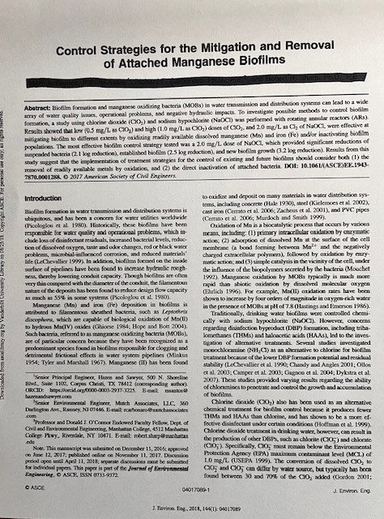

HOW TO NOMINATE AN INDIVIDUAL

The following instructions are for those nominating a person for an award.

Step 1 – Completed on page 11.

Step 2 - Before proceeding further answer these questions:

- Does the award you have identified require ASCE membership? If so, does your candidate meet this requirement? _____YES _____NO

- Does the award have an age requirement? If so, does your candidate meet this requirement?
_____YES _____NO

Step 3 – Your complete nomination package must include:
- Your cover letter describing how your candidate meets or exceeds the award’s criteria. Because your package will include the candidate’s bio or CV, do not repeat their background.
- A completed Official Nomination Form (available at https://www.asce.org/-/media/asce-images-and-files/career-and-growth/awards--and-honors/documents/asce-official-award-nomination-form.pdf). See next page for information about citations.
- Two-three reference letters, in which recommenders offer how the candidate meets the award criteria.
- The candidate’s bio or CV. Please limit it to no more than 25 pages.
- As the nominator, provide your contact information and signature to the Official Nomination Form.

Step 4 - Submit your complete package (single PDF preferred) to awards@asce.org.

Step 5 - Once submitted, you will receive acknowledgement, generally within 24 hours. If you have not received notification, please follow up.

Questions? Contact awards@asce.org.

The Importance of Citations

In the case of nominations for individuals, citations play an important role.
  - The citation is used as a rationale for why the candidate is being recommended as a winner.
  - The citation is used in ASCE publicity about the winner.
  - The citation appears on the winner’s certificate if the award provides for one.

The citation is no more than 40 words in length and always begins with “For” as shown in the following examples:

“For her technical accomplishments, leadership, and commitment to mentoring women pursuing engineering careers which concur with the ideals the award’s namesake championed throughout her life.”

“For technical contributions of national and international significance in risk analysis, risk management and lifecycle economics of civil infrastructure, including resilience and sustainability in a changing climate.”

“For his exceptional wide-ranging research on arid lands hydrology and hydraulics, including analyzing the vulnerability of the U.S. water supply system to climate change, and observationally demonstrating the complementary relationship of evapotranspiration, and for his outstanding teaching and mentoring.”

“For fundamental contributions to advancing the science on the fate and transport of polyfluoroalkyl substances (PFAS) and other emerging contaminants in aquatic and terrestrial systems that leads to guidelines and models for subsurface remediation.”

“For seminal work on theoretical and computational methods related to wave propagation and inverse scattering problems, with applications to the imagining of biological and engineered systems.”

EXAMPLE – NOMINATION FOR AN INDIVIDUAL

Pages 20 to 23 are provided as reference.

Template – Nominator’s cover letter

On your letterhead, if available for this purpose.

INSERT DATE HERE

Honors and Awards Program
ASCE
1801 Alexander Bell Drive
Reston, VA 20191-4400

Dear Selection Committee:

INSERT INTRODUCTORY PARAGRAPH HERE (e.g.: I am pleased to nominate INSERT CANDIDATE’S NAME for the INSERT NAME OF AWARD HERE.)

TWO - FOUR PARAGRAPHS HERE THAT JUSTIFY HOW YOUR CANDIDATE MEETS THE AWARD’S CRITERIA. AS YOUR PACKAGE WILL INCLUDE THE CANDIDATE’S CV, THERE IS NO NEED TO REPEAT IT HERE. INSTEAD, WE SUGGEST DISCRIBING THE IMPACT THEY HAVE HAD ON THEIR ENGINEERING DISCIPLINE, THEIR IMPORTANT RESEARCH OR ACCOMPLISHMENTS, ETC.

INSERT CLOSING PARAGRAPH HERE (e.g.: I recommend without qualification the paper Roberta Necessary for the Stephen D. Bechtel Pipeline Engineering Award.)

Sincerely,

your signature

TYPE YOUR NAME AND CREDENTIALS HERE (e.g. Thelma Joyful, P.E., F.ASCE)

Example – Author’s nomination form

OFFICIAL AWARD NOMINATION FORM
Please complete this form for each person being nominated.

Stephen D. Bechtel Pipeline Engineering Award
Award Name
Name: _ George T. Great, P.E., M.ASCE
Nominee’s Full Name (add credentials, including ASCE membership grade. Example: Ph.D., P.E., M.ASCE)

Home Address: 9142 West Park Drive, Ashburgh, NM 92843

Email: george_great@gmail.com

Birth date – if an award requirement: _________________________________________

Provide Information About Professional Licensure (P.E. - Primary):
License State: __________________License #:____________________Year_______

Provide ASCE Membership Grade:
___ Dist.M.ASCE (Distinguished Member) ___ A.M.ASCE (Associate Member)
___F.ASCE (Fellow) ___ Aff.M.ASCE (Affiliate Member)
X__M.ASCE (Member) ___ S.M.ASCE (Student Member)
___ Not Society Member

Suggested Citation (not to exceed 40 words):
“For his many contributions in the field of pipe material engineering, research and evaluation, pipeline engineering and construction and for his work on national committees and organizations.”

Nominated by: Thelma Joyful, P.E., F.ASCE ______________________________
Name Signature

Phone: 844-123-9865 Email: _tj@gmail.com___ Date: 10/20/2023
Example – Reference letter. You will need 2-3 letters. Authors should be those who can speak with authority about the qualifications of the candidate. Letters should be original and should not duplicate one another. Reference letters must be collected by the nominator and included in the final package.

On your letterhead, if available for this purpose.

INSERT DATE HERE

Honors and Awards Program
ASCE
1801 Alexander Bell Drive
Reston, VA 20191-4400

Dear Selection Committee:

INSERT INTRODUCTORY PARAGRAPH HERE (e.g.: I am pleased to recommend INSERT CANDIDATE'S NAME for the INSERT AWARD NAME.)

TWO - FOUR PARAGRAPHS HERE THAT JUSTIFY HOW YOUR CANDIDATE MEETS THE AWARD’S CRITERIA. AS THE FINAL NOMINATION PACKAGE WILL INCLUDE THE CANDIDATE’S CV, THERE IS NO NEED TO REPEAT IT HERE. INSTEAD, WE SUGGEST DISCRIBING THE IMPACT THEY HAVE HAD ON THEIR ENGINEERING DISCIPLINE, THEIR IMPORTANT RESEARCH OR ACCOMPLISHMENTS, ETC.

INSERT CLOSING PARAGRAPH HERE (e.g.: I recommend without qualification George Great for the Stephen D. Bechtel Pipeline Engineering Award.)

Sincerely,

your signature

TYPE YOUR NAME AND CREDENTIALS HERE (e.g. Thelma Joyful, P.E., F.ASCE

The final document in this submission is the candidate’s CV/bio
Please limit it to no more than 25 pages.

HOW TO NOMINATE A PROJECT

ASCE has two Society Awards for projects. They are Innovation in Sustainable Engineering Award and Outstanding Civil Engineering Achievement Award.

The Official Nomination form is not used for this entry.

For the Innovation in Sustainable Engineering Award, use the form available at
https://www.asce.org/-/media/asce-images-and-files/career-and-growth/awards--and-honors/documents/innovation-in-sustainable-engineering-award-nomination-form.pdf

For the Outstanding Civil Engineering Achievement Award, use the form available at
https://www.asce.org/-/media/asce-images-and-files/career-and-growth/awards--and-honors/documents/ocea-award-nomination-form.pdf

The following example applies to the Innovation in Sustainable Engineering Award, but also applies to the Outstanding Civil Engineering Achievement Award.

Step 1 – Completed on page 11.

Step 2 – Your complete nomination package must include:
- Your cover letter as described in the entry form.
- A completed entry form.
- Photos as described in the entry form.

Step 3 - Submit your complete package (single PDF preferred) to awards@asce.org.

Step 4 - Once submitted, you will receive acknowledgement, generally within 24 hours. If you have not received notification, please follow up.

Questions? Contact awards@asce.org.

EXAMPLE – NOMINATION FOR A PROJECT

Pages 26 to 30 are provided as reference.

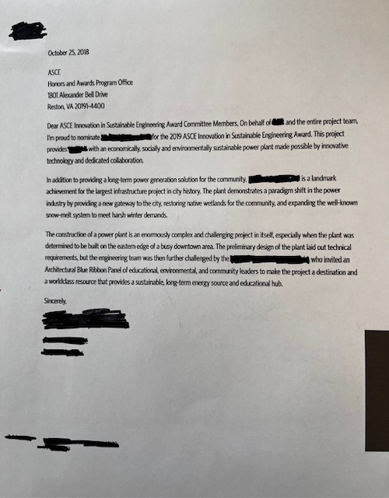

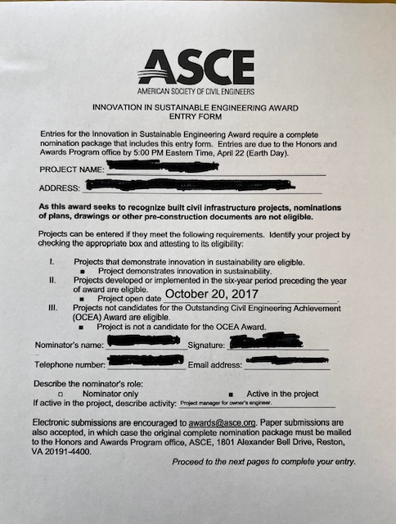

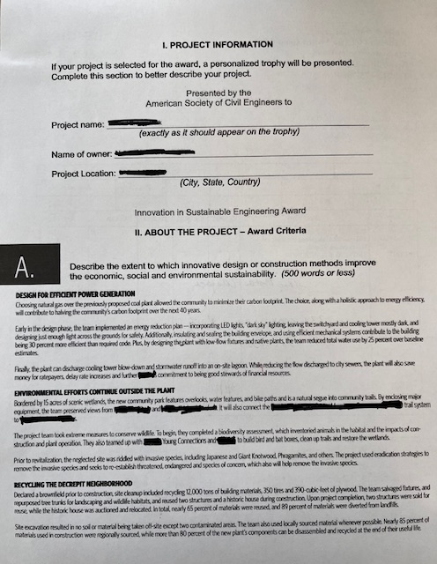

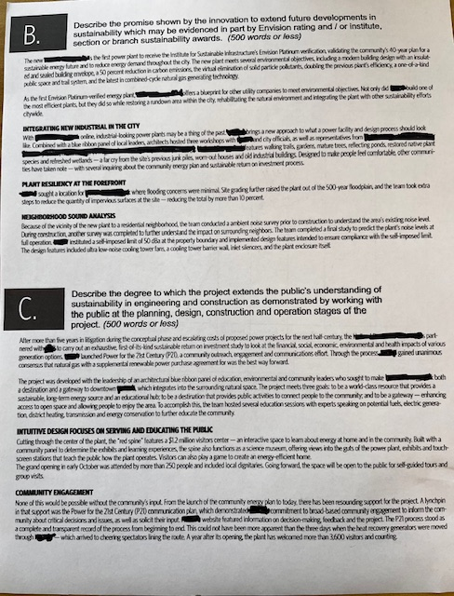

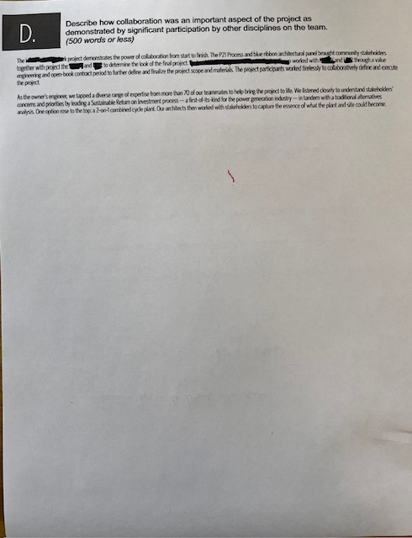

HOW TO NOMINATE AN EDUCATIONAL PROGRAM

ASCE has one Society Award for an educational program. It is the Walter LeFevre Award.

The Official Nomination form is not used for this entry.

Instead, you will use the award-specific form available on the award’s website: https://www.asce.org/-/media/asce-images-and-files/career-and-growth/awards--and-honors/documents/walter-lefevre-award-nomination-form.pdf

Step 1 – Completed on page 11.

Step 2 – Your complete nomination package must include:
- A completed entry form.
- Attachments described in the entry form.

Step 3 - Submit your complete package (single PDF preferred) to awards@asce.org.

Step 4 - Once submitted, you will receive acknowledgement, generally within 24 hours. If you have not received notification, please follow up.

Questions? Contact awards@asce.org.

EXAMPLE – NOMINATION FOR AN EDUCATIONAL PROGRAM

Pages 33 to 37 are provided as reference.

